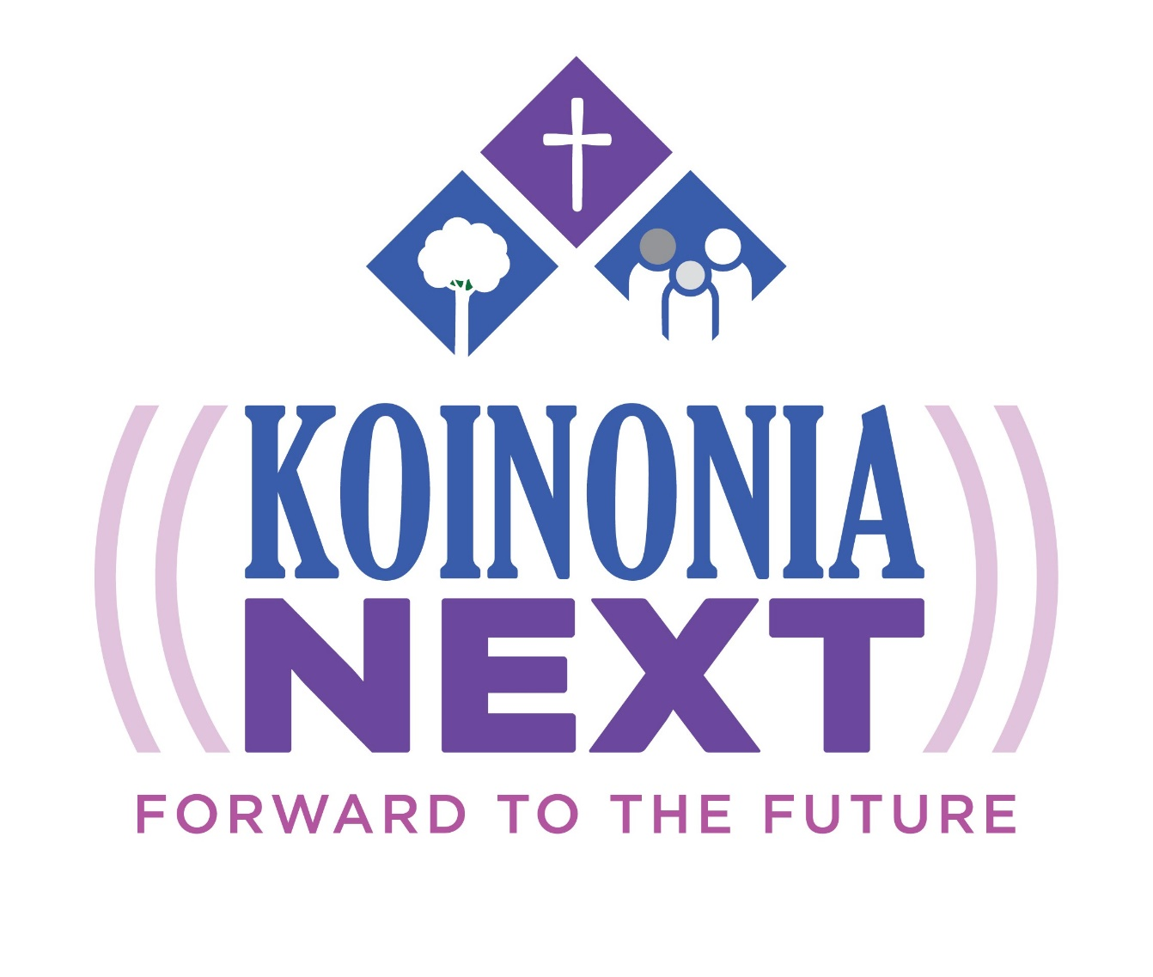
Appendices to the Congregation Leader Manual

APPENDIX A

First Congregational Letter

Dear Member of __________ Lutheran Church,

One of the finest ministries we provide to children and families in the Church is Christian outdoor ministries.

Since its founding in the 1960’s, our outdoor ministry, Koinonia, has provided a setting and programs where Christ's love has been shared, where faith has been nurtured in a community of faith, and where lives of children and families have been strengthened in faith.

Now as Koinonia is engaged in the Koinonia NEXT capital campaign, we have an opportunity to strengthen this ministry for serving people of all ages for generations to come.

During the next five weeks, you will learn more about the campaign. We pray that your commitment to ministry will encourage you to become involved as we learn more about this exciting opportunity in the weeks ahead.

Yours in Christ,

(signed by Congregation Leader
and/or Pastor and/or Council Chair)

APPENDIX B

Second Congregational Letter
(See Appendix C for Phone-a-thon letter)

Dear fellow members,

We are in the process of learning more about the great opportunity now before us at Koinonia.

Through experiences at Koinonia, youth, adults and families have been touched by God’s love – both directly and indirectly. Many of our members grew in their faith when they attended camp as children and they now serve as teachers, role models and leaders in our churches.

The Koinonia NEXT campaign has been established to fund and improved facilities and infrastructure. These improvements and investment in leadership and program development will greatly enhance Koinonia’s capacity to serve.

On (date), we will join Lutherans from across our area in supporting this important effort. Our congregation has set a goal of $(__), and we firmly believe we can reach or even exceed that goal. Pledges can be made over a 3-year period of time.

So far, more than $1 million has been raised for this exciting effort. Now it is our turn!

We will be receiving commitments from the members of our congregation . . . (explain the method and timing of your response plan).

I look forward to you joining us in supporting the campaign. I hope you can be generous and please know that your contribution, of any amount, will be much appreciated. We hope that many more children, youth, families and adults will participate in programs and retreats at Koinonia for generations to come as a result of this campaign.
In Christ,

Pastor/Campaign Leader

APPENDIX C

Second Congregational Letter
(Only if you are conducting a phone-a-thon)

Dear fellow members,

We are in the process of learning more about the great opportunity now before us at Koinonia.

Through experiences at Koinonia, youth, adults and families have been touched by God’s love – both directly and indirectly. Many of our members grew in their faith when they attended camp as children and they now serve as teachers, role models and leaders in our churches.

The Koinonia NEXT campaign has been established to fund and improved facilities and infrastructure. These improvements and investment in leadership and program development will greatly enhance Koinonia’s capacity to serve.

On (date), we will join Lutherans from across our area in supporting this important effort. Our congregation has set a goal of $(__), and we firmly believe we can reach or even exceed that goal. Pledges can be made over a 3-year period of time.

So far, more than $1 million has been raised for this exciting effort. Now it is our turn!

We will be receiving commitments from the members of our congregation through a “phone-a-thon” to families of the congregation. On (date), between the hours of (times), a member of the congregation will phone you to ask you to consider a pledge to Koinonia NEXT.

I look forward to you joining us in supporting the campaign. I hope you can be generous and please know that your contribution, of any amount, will be much appreciated. We hope that many more children, youth, families and adults will participate in programs and retreats at Koinonia for generations to come as a result of this campaign.
In Christ,

Pastor/Campaign Leader

Appendix D
Letter to those who don’t return a pledge card on Commitment Sunday
Enclose a pledge form

Date
Dear Member of (xxx) Church Family,

On Sunday, (xxx) families participated in the Koinonia NEXT campaign raising over ($XXX) to help complete the funding for the enhanced ministry facilities and strengthened programs at Koinonia. Gifts ranged from $xx to $xx and averaged $(xxx) per family! Thank you to all who have already participated.

When we approved participating in this campaign, we hoped that all families at (church) would hear the story of the campaign and make a commitment in some way.

We have certainly heard the story and know that these improvements will be a wonderful resource for meaningful ministry that will touch thousands of lives for generations.

I hope you will join me in making a commitment to this endeavor. Did you know that 40% of today’s seminarians worked on an outdoor ministry staff? Many of those were Koinonia staff members in the past. Did you know that a Search Institute Study found that except for the faith of parents, a week of outdoor ministry ranks as the most important event a child can experience to remain faithful through their lives?

Please join all the families who made commitments on Sunday so that our response to Koinonia NEXT will reflect the best effort of our congregation. Together, we can make a significant difference that will touch many lives with the good news of Jesus Christ for generations to come.

Please fill out the enclosed pledge card and place it in the offering plate on Sunday or return it during the week to the church office. Your commitment should be returned to the church office by (Date), or we will follow up with you by phone to learn of your intentions.

Sincerely,

(Name), Campaign Chair

Appendix E

Temple Talk I – A History of Faithful Service And Ministry Growth!

Koinonia was established in 1963 by 40 Lutheran Congregations in New Jersey, New York, and Pennsylvania.

The first 1,063 acres were purchased for $10,000. Another 300 acres were purchased in 1963-nearly 1200 acres of wilderness in the lower Catskills of Sullivan County to enjoy.

The first executive director of Koinonia, Jerry Manlove, was a tremendous influence on Lutheran Outdoor ministry and is Nationally known.

Thousands of campers, confirmation & youth groups, congregations, and families have experienced Christ through the ministry of Koinonia.

Faith building experiences happen through summer camp and retreats.

Currently we have over 50 member congregations who participate in our ministry from New Jersey, New York, and Pennsylvania

You’ll notice in the bulletin insert –

As I saw the history of Koinonia, it made me think of my own relationship with the Ministry, and my own Koinonia stories. (Insert personal impact Koinonia has had on you here.)

I have a question for you to ponder – What has your relationship been with Koinonia? If there is none – isn’t now the time to start your own Koinonia story?

APPENDIX F
Temple Talk II – KOINONIA NEXT:FORWARD TO THE FUTURE

Day Campers and Youth at Koinonia have needs:

Training and certification for all of our staff, including waterfront directors & lifeguards.

A beautiful Waterfront and beach area that children and youth can enjoy.

Office staff, counselors, and Maintenance staff to keep everything running well.

Scholarships for families so everyone who wants to come to Koinonia can!

A freshened-up Staff house to begin our Aftercare program

Congregations and retreat guests staying at the Conference Center have needs!

High speed wifi, individual air/heating units, new roofs, replaced wells, septic systems, fresh paint make visits comfortable.

Cleaning staff, maintenance staff and cooking staff keep buildings in good condition and guests well fed.

Spring, Summer, and Fall weekend rentals are increasing, we will need to hire staff to meet these needs.

Koinonia, as a re-start up, has needs that other organizations do not.

Due to the camp closing in 2018, there was a huge investment to just get the camp re-opened.

Koinonia needs to replace endowment funds that were used in hard times.

Koinonia is on an upward trajectory and your support will make sure it reaches stability within 5 years.

A question for you to ponder today. . . When you are starting something new (a new job, a new school year-what kind of supports do you need?

APPENDIX G
Temple Talk III – KOINONIA NEXT:FORWARD TO THE FUTURE

To date, the campaign has received over ($XXX) in cash and pledges. (Call and speak with Kathleen or Lora at 845.465.0214 or email lora@koinoniany.org to get the latest total.)

With the success of the campaign so far – I’m happy to report all the projects on our original list have been completed or begun..

But there’s more to do! The campaign stretch goal is $500,000 and so now it’s our turn to respond.

When this remainder is received, we will be able to begin work on the shower house, which will have four flush toilets, two showers, electricity and heat!

Our congregation has set a goal to raise ($XXX) toward this effort.

Next weekend, we will be receiving commitments for the Koinonia NEXT: Forward to the Future campaign from the families of our congregations.

Each family will have the opportunity to respond with a three-year pledge or a one-time gift. With all of us responding, our goal can be met and we will have significantly helped to meet the Koinonia NEXT: Forward to the Future goal.

I have a question for you to ponder. . . How will you respond to this campaign?
Appendix H
Temple Talk IV
(Talk prior to intent forms being filled out)

For the past four weeks, we have heard about the plans for enhanced and upgraded facilities at Koinonia. We have heard about the great difference that these improvements will make for guests of all ages.

We have also heard that many individuals, families and congregations from across the area have provided support to the Koinonia NEXT campaign. A total of $(*amount) has already been pledged and given to support this effort. Now, it is our turn. Our congregation has set a goal of ($xxx) to help fund this exciting venture.

You have a three-part statement of intent form, (Hold up the form.) Please complete your statement of intent form. And, even if you are unable to give at this time, we ask you to put your name on the card and write “no gift at this time” and return it so that we know not to follow up with you any further.

Your intent card will be sent by the church to the campaign office. They will acknowledge your gift and provide you envelopes to mail your payments directly to the campaign office.

In just a few moments the children will bring baskets around to collect intent cards from everyone (or, you will come forward with your pledge in a processional). Please join me now in supporting “Koinonia NEXT.”

NOTE:
*Please call the office 845.456.0124 or email lora@koinoniany.org prior to Commitment Sunday and get an updated total of what has been pledged and given to the campaign.

Appendix I
Fillers for Bulletin and Monthly Newsletters – Fun Facts

Did you know that Koinonia is celebrating its 60th anniversary this year?

Did you know…in the past two years Koinonia has more than doubled its impact on congregations, day campers, and visits to congregations?

Did you know that Koinonia is in partnership with the local Town of Highland, helping to offset costs for childcare programs and creating a warming center on site?

Koinonia’s mission statement is “Where God transforms and prepares people in an outdoor environment to love and serve one another.”

Koinonia is a place where many families have gone for years, had huge family reunions, and been engaged for more than three generations.

40% of today’s seminarians worked on a camp staff. 75% of pastoral leaders lifted up experience at summer camp as one of the major reasons they followed the call to ordained ministry.

A Search Institute study found that except for their parents’ faith, a week at camp ranks as the most important event a child can experience in remaining rooted in their Christian faith through their lives.

Koinonia’s Nature Camp is running for the entire summer-10 weeks-so it can be an option for families who work and need childcare.

Koinonia has miles of trails to explore, and a 2-mile lake that is fully enclosed by the property. We have canoes, kayaks, and rowboats.

Koinonia is a great place to fish, to hike, to boat, and to enjoy fun activities in an outdoor environment.

APPENDIX J

Suggested Commissioning Service
(Feel Free to use part or all of this service)
Ask the Koinonia NEXT Campaign workers to come to the front.

Beloved in the Lord:
You have been chosen for the very important responsibility of contacting the members of this congregation to receive their gifts for strengthening Koinonia’s programs for children, adults and families. By your presence, you are signifying your acceptance of this responsibility before God.
May God bless your mission. May God grant you courage to bring to each member and to this entire congregation the challenge of this responsibility so that our children, adults and families may know hope, faith and spiritual growth in their lives. May God prosper you that your mission shall meet with a full measure of success to the honor and glory of God.

Let us hear the Word of God concerning the stewardship of means:

"Honor the Lord with your substance, and with the first fruits of all your produce." Prov. 3:9

"As you did it to one of the least of these my brethren, you did it to me." Matt. 25:40

"The point is this: He who sows sparingly will also reap sparingly, and he who sows bountifully will also reap bountifully. Each one must do as he has made up his mind, not reluctantly or under compulsion, for God loves a cheerful giver." II Cor. 9:6-7

I ask you now, will you accept this task to which you have been called and, praying God to guide you on your way, carry out this mission to the glory of God and to the full extent of your ability, until all the members of this congregation have been given the opportunity to share in this work?

If so, answer YES.

Will the congregation please stand:

I ask you also, on whose behalf these fellow members shall contact you in the interest of thousands of children, adults and families who will be served through Koinonia in the decades to come, will you receive them as messengers doing God's will; and will you accept the challenge God has given to this congregation, giving of your substance as God has prospered you and as the Word of God sets forth?

If so, answer YES.

Let us pray:
Heavenly Father, we pray that you will make us worthy members of your church, who by both word and deed glorify Your Name. We pray you to bless these, your servants who today go out to ask for gifts that shall enable us better to serve your people. Touch the hearts of those they shall visit, that their mission may be lightened and made joyous.

Grant every member of this congregation a vision of the importance of the work in which we are engaged and help us all that we may share to the full extent of our abilities. Prosper us in every good work. "And let the favor of the Lord our God be upon us." In the Name of Jesus Christ, your Son, our Lord. AMEN.

Closing Comment and/or Blessing
APPENDIX K

Sample Thank You Letter

Dear member of ________________________ Church,

Thank you so much for your contribution to the Koinonia NEXT campaign.

Your gift is an investment in the future ministry of Koinonia for years to come.

To date, our congregation has generated $ ________ in gifts and commitments to the campaign effort. We hope that more members may respond in the next few weeks.

You will be receiving acknowledgement of your gift from the Koinonia campaign office in the near future. They will also send you periodic updates on the campaign progress and the improvements made possible through your generosity.

Thank you again for your partnership in this effort.

Sincerely,

(Congregation leader/Committee members/pastor, etc.)

(Reminder: If the donor has not received or kept a copy of their pledge form be sure to enclose it with this letter.)

